**“The Store”**

We have merchandise for sale in the clubhouse.

These items make great gift ideas.

Come in and check it out.

Clubhouse hours are 9-12 Wed am, 6-9 Wed pm, Sat and Sun 10-2.



* Sticker – $1.25
* Key Ring – 5.00
* Hat – $15.00
* Pen – 1.75
* Mug – $6.00
* Shirt – 15.00

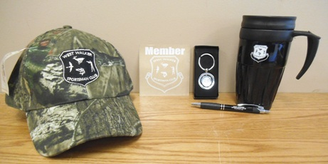

*Hat may not be representative of what is currently in stock